**Badge Box Testing in STB: A Basic Tutorial**

*By: Noel Affonso*

The badge box is a physical accessory that interfaces with a test device (MFP/printer) via USB and enables proximity card (badge) authentication for up to four cards (users). It contains slots (0-3) to hold up to four proximity cards, a bracket to hold an HP proximity card reader, and the attendant internal board/chips/ports. STB can leverage the badge box to allow scenarios to use card authentication at the connected device, for pull print/authentication solutions like Equitrac, HPAC, and SafeCom. (Equitrac requires a specific Equitrac-branded card reader, in addition to a specially-configured badge box.)

This guide will outline a basic end-to-end workflow for using a badge box in an STB scenario, to include initial setup steps.

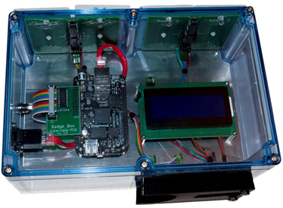

**Section 1: Badge Box Physical Setup and Configuration**

1. For the device to be tested with the badge box, ensure that it is loaded with the desired authentication solution (HPAC, SafeCom) and correctly configured for card authentication. Any cards to be used with the badge box in step 3 below will need to be enrolled to this authentication solution. With either an HP CZ208A or HP X3D03A proximity card reader connected to the device via USB, manually verify that card authentication is successful on the device (the enrolled user should appear on-screen after reading the card).

* Equitrac is also supported, but this requires a specific Equitrac-branded card reader, in addition to a specially-configured badge box.

1. Determine if testing with the iClass card type. Note that only slot 3 on the badge box supports iClass. If testing with iClass on slot 3, ensure that the jumper settings for the slot 2/3 circuit board are configured as shown at left in the image below. If not testing with iClass on slot 3, ensure that the jumper settings for the slot 2/3 circuit board are configured as shown at right in the image below. If necessary, mount the jumper caps on the jumper pins as indicated in the image, for the desired configuration.

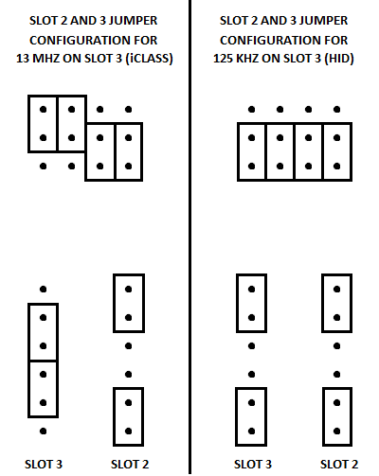

1. Add up to four proximity cards into slots 0-3 on the back of the badge box. Corresponding to each slot are clear plastic sleeves that cards can be inserted into – the orientation of the cards generally does not matter.
2. Keeping the HP proximity card reader from step 1 connected to the device, insert that reader into the bracket on the side of the badge box, with the led indicator light on the reader facing in.
3. Connect the badge box to a network, plug in the power cord, and then wait a few minutes while observing the badge box’s LCD display. If DHCP is enabled on the network, or if a static IP address has already been assigned to the badge box, then an IP address will be displayed. If DHCP is not enabled on the network, a static IP address has not yet been assigned, or the badge box can’t connect to the network (a bad cable, for example), the MAC address of the badge box will instead be displayed. Ensure that the badge box is displaying an IP address before proceeding.
4. Verify that the badge box’s embedded web page is working correctly, by entering the IP address displayed on the badge box into a web browser on the same network as the badge box.
5. Click the **Rfid** header on the badge box web page. On the **Rfid Switch** page that appears, note the **light sensor** item at middle-left, and then click the **set light sensor** option at bottom-left. By default, and also after the badge box loses power, these will display the value “sensor1”.
6. If using an HP CZ208A proximity card reader, no further action is needed. If using an HP X3D03A proximity card reader, change the value to “sensor2” and click the  button underneath to apply the change. Afterward, both **light sensor** and **set light sensor** should indicate “sensor2”.

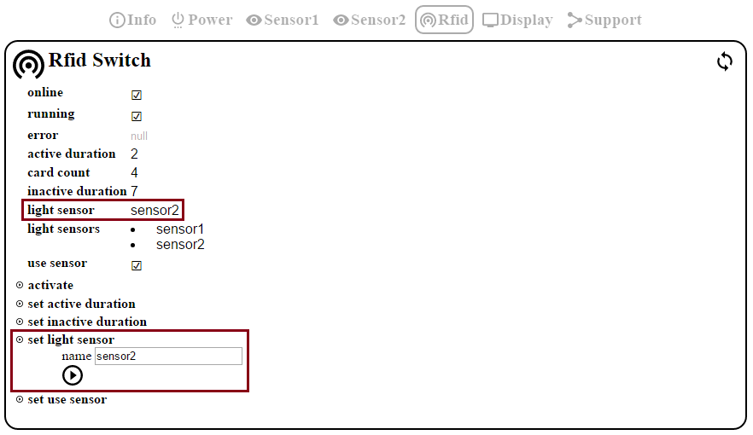

**Section 2: Print Device Inventory**

1. Open the **STB Admin Control Panel** application, and then navigate to the **Badge Boxes** page by clicking the Badge Box Inventory link under **Print Automation**.

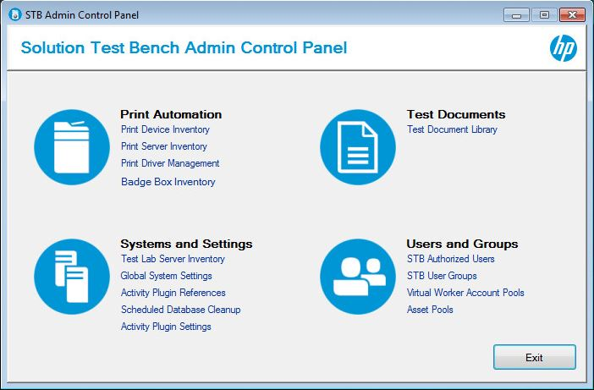

1. Ensure that the badge box is listed here, or otherwise add an entry using the **Add** button at top of the grid labeled **Badge Boxes**. Ensure that all fields including **Printer ID** are populated with correct values, in order for the badge box to work correctly with STB. An existing entry can be modified by clicking on the **Edit** button.

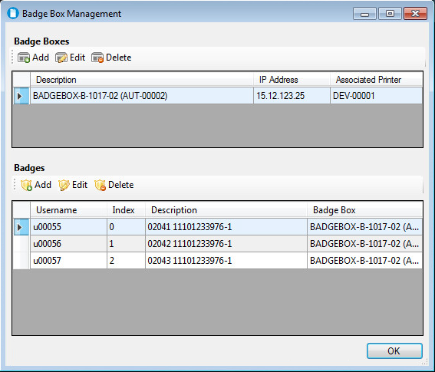

1. Ensure that any cards inserted into the badge box are listed here, or otherwise add an entry using the **Add** button at the top of the grid labeled **Badges**. Ensure that all fields including **Badge Box** are populated with correct values, in order for the badge box to work correctly with STB. An existing entry can be modified by clicking the **Edit** button.



1. Close the **STB Admin Control Panel** and return to or open the **STB User Console**. From the main menu, click on **Administration**, then click on **Virtual Worker Account Pools** at the bottom of the dropdown menu.

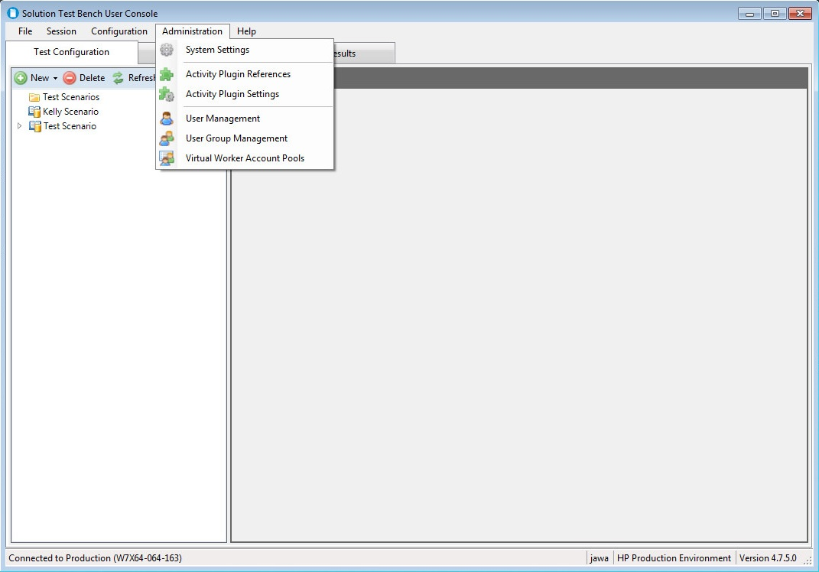

1. Ensure that a user pool is listed here, that corresponds to the user(s) enrolled to card(s) in Section 1, or otherwise add an entry using the **Add** button at top. An existing entry can be modified by clicking the **Edit** button at top.

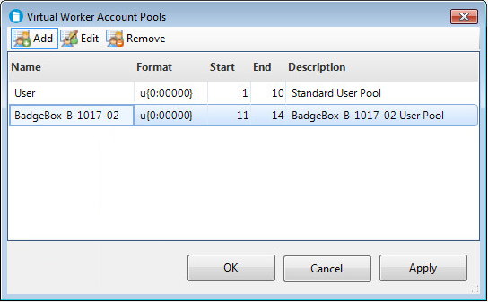

**Section 3: STB Setup**

1. To leverage badge/card authentication in STB, a scenario must first be configured with an OfficeWorker that utilizes one of the following plugins:

* **Authentication** plugin
* **EquitracPullPrinting** plugin
* **HPACPullPrinting** plugin
* **SafeComPullPrinting** plugin

1. For the OfficeWorker, in the **Execution Parameters** tab, set the **Total Workers** field to match the number of cards in the badge box.

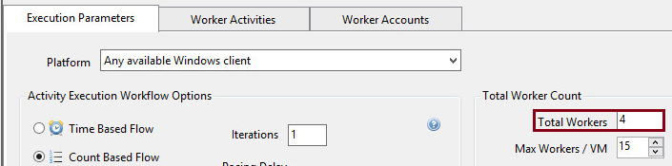

1. For the OfficeWorker, in the **Worker Accounts** tab, click the **User Pool** drop-down, select the user pool from Section 2, and click **Save**.

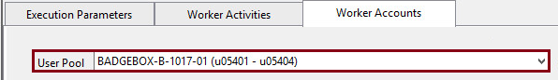

1. For the **Authentication** plugin, click the **Authentication Initiation Button** drop-down, select “Badge”, and click **Save**. Note that doing this also automatically populates the **Authentication Method** drop-down with the “Proximity Card” value.

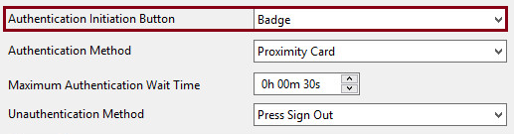

1. For the **EquitracPullPrinting**, **HPACPullPrinting**, and **SafeComPullPrinting** plugins, click the **Authentication Method** drop-down, select “Proximity Card”, and click **Save**.

